##Build libuvc for Linux and RICOH THETA V Live Streaming

1.
2. type ‘l’ on terminal, then you can see libuvc-theta/

3. type below code on terminal
cd libuvc-theta/
git branch -a
git checkout theta_uvc
mkdir build
cd build/
cmake ..
sudo make install
cd ..
cd ..
git clone https://github.com/ricohapi/libuvc-theta-sample.git
4.type ‘l’ on terminal, then you can see libuvc-theta/ and libuvc-theta-sample/
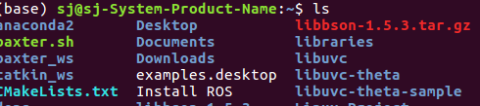

5. type below code on terminal
cd libuvc-theta-sample/gst
pwd
make

I got error in this part, solved it by following below code
#error1
error message : gst_viewer.c:38:21: fatal error: gst/gst.h: No such file or directory
code :
#error2
error message : /usr/bin/ld: warning: libjpeg.so.9, needed by /usr/local/lib/libuvc.so, not found (try using -rpath or -rpath-link)
code : sudo apt-get install libjpeg9

17. type ‘make’ on terminal again
18. ls
If you can see gst_viewer, it's done
19. Turn on RICHO THETA V and change mode to 'live streaming'
20. type ‘./gst_viewer’
